Step 1: Rockbuster ERD

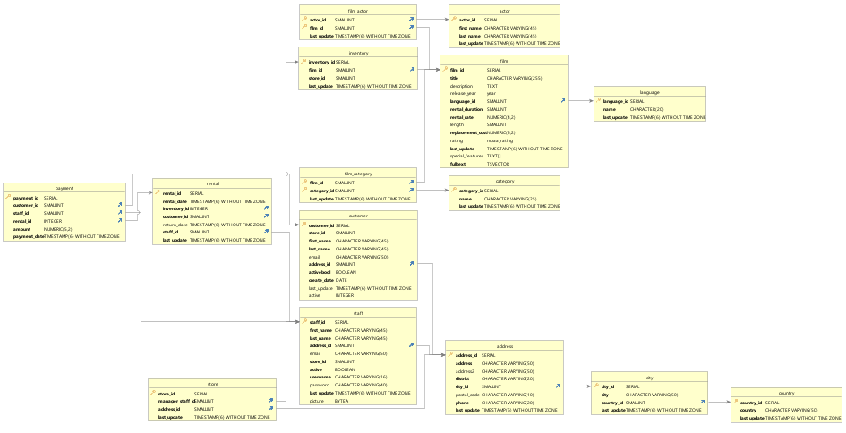

Step 2: Create the first draft of a data dictionary

* **Take a moment to examine your ERD. Does the Rockbuster database have a snowflake schema or a star schema? Write a brief explanation for your answer.**

It is a snowflake schema because it provides multiple links connected to each other.

* List all the fact tables and all the dimension tables in the schema. For each table, list every column and its data type, and write a brief description of the column.

|  |  |  |  |
| --- | --- | --- | --- |
| **Fact Tables** | **Column** | **Data Types** | **Description** |
| Payment | Payment_id | Serial | Identifies payment |
|  | Customer_id | Smallint | Identifies customer |
|  | staff_id | Smallint | Identifies staff |
|  | rental_id | Integer | Identifies rental |
|  | Amount | Numerics | Amount paid |
|  | Payment_date | Timestamp without timezone | When it was paid |
| Rental | Rental_id | Serial | Identifies rental |
|  | Rental_date | Timestamp without timezone | When it was rented |
|  | inventory_id | Integer | Identifies inventory |
|  | customer_id | Smallint | Identifies customer |
|  | Return_date | Timestamp without timezone | Date it was returned |
|  | staff_id | Smallint | Identifies staff |
|  | Last_update | Timestamp without timezone | Date it was last updated |

|  |  |  |  |
| --- | --- | --- | --- |
| **Dimension Tables** | **Column** | **Data Types** | **Description** |
| Film_actor | Actor_id | smallint | Identifies actor |
|  | Film_idq | Smallint | Identifies film |
|  | Last_update | Timestamp without timezone | Date it was last updated |
| Inventory | Inventory_id | Serial | Identifies inventory |
|  | Film_id | Smallint | Identifies film |
|  | Store_id | Smallint | Identifies Store |
|  | Last_update | Timestamp without timezone | Date it was last updated |
| Film_category | Film_id | Smallint | Identifies film |
|  | Category_id | Smallint | Identifies category |
|  | Last update | Timestamp without timezone | Date it was last updated |
| Customer | Customer_id | Serial | Identifies Customer |
|  | Store_id | Smallint | Identifies store |
|  | First_name | Character varying | Provides customer name |
|  | Last_name | Character varying | Provides customer name |
|  | Email | Character varying | Provides customer email |
|  | Address_id | Smallint | Provides customer address |
|  | Activebool | Boolean |  |
|  | Create_date | Date | Date record was created |
|  | Last_update | Timestamp without timezone | Date it was last updated |
|  | Active | Integer | Info if client is active or not |
| Staff | staff_id | serial | Identifies staff |
|  | First_name | Character varying | Provides customer name |
|  | Last_name | Character varying | Provides customer name |
|  | Address_id | Smallint | Provides customer address |
|  | Email | Character varying | Provides customer email |
|  | Store_id | Smallint | Identifies store |
|  | Active | Boolean | Info if staff is active or not |
|  | Username | Character varying | Staff username |
|  | Password | Character varying | Staff password |
|  | Last_update | Timestamp without timezone | Date it was last updated |
|  | Picture | BYTEA | Shows staff piture |
| Actor | Actor_id | smallint | Identifies actor |
|  | First_name | Character varying | Provides actor name |
|  | Last_name | Character varying | Provides actor name |
|  | Last_update | Timestamp without timezone | Date it was last updated |
| Film | Film_id | serial | Identifies film |
|  | Title | Character varying | Provides film title |
|  | Description | Text | Provides film description |
|  | Release_year | Year | Date film was released |
|  | Language_id | Smallint | What language is spoken |
|  | Rental_duration | Smallint | How long it was rented for |
|  | Rental_rate | Numeric(4,2) | How often its rented |
|  | Length | Smallint | How long the film is |
|  | Replacement cost | Numeric(5,2) | How much to replace film |
|  | Rating | Mpaa_rating | What the movie is rated |
|  | Last_update | Timestamp without timezone | Date it was last updated |
|  | Special features | Text[] | Features film contains |
|  | fulltext | tsvector | Full text index |
| Category | Category_id | Smallint | Identifies category |
|  | name | Character varying | Provides actor name |
|  | Last_update | Timestamp without timezone | Date it was last updated |
| Language | Language_id | Serial | Language spoken in film |
|  | Name | Character | Name of film |
|  | Last_update | Timestamp without timezone | Date it was last updated |
| Address | Address_id | Serial | Identifier for address |
|  | Address | Character varying | Address option |
|  | Address_2 | Character varying | Second address option |
|  | District | Character varying | Identifies district |
|  | City_id | Smallint | Identifies City |
|  | Postal_code | Character varying | Identifies postal code |
|  | Phone | Character varying | phone # |
|  | Last_update | Timestamp without timezone | Date it was last updated |
| City | City_id | Serial | Identifies city |
|  | City | Character varying | City name |
|  | Contry_id | Smallint | Country name |
|  | Last_update | Timestamp without timezone | Date it was last updated |

* If a column name doesn't tell you enough to write a description, you can also view the tables in pgAdmin 4. The SQL syntax for selecting a table is SELECT * FROM table_name. So, SELECT * FROM film would return the film table, for example.

Step 3:

Now that your data dictionary and ERD are ready to use, your manager has given you a list of business questions to answer. Use your data dictionary to figure out which tables you'd need to answer the questions below:

**Which actors brought Rockbuster the most revenue?**

I would look in: Rental, payment, actor.

**What language are the majority of movies in the collection?**

I would look in: Inventory, film, language